**Football Team Management**

Databases project

Sabrina Lupsan

Faculty of Cybernetics, Statistics and Economic Informatics

Series G

Group 1064

**Description of the theme**

I chose to make a database of a Football Team and learned how to manage it. The players have four different kind of jobs, based on real-life evaluation and strategies – goalkeeper, midfielder, defender and attacker. The minimum and maximum salary of each job depend on the job and the net salaries were calculated using the gross salary and the taxes applied. Each team has players, a sponsor, matches played. The matches were played in different stadiums, and those stadiums are in different countries. This is how it all ties together, bringing the management of a Football Team. I believe that such a database is useful for storing data for official competitions like Champions League or The World Championship, which need official data, and for media news, who need statistics, such as the ones displayed in the exercises given.

For the economic part, rather than the management part, I used economic indicators such as: calculation of net salary based on gross salary and the imposed taxes, computation of the most profitable career based on monthly earning (considering salary, bonuses etc.), amount of taxes payed by each team, restricted to taxes on salaries.

All of the teams and names were fictious and the salaries chosen for this database are not official or true.

**The conceptual scheme of the database**

A database always begins with a conceptual scheme, which helps design and organize the coding part. This also helps identify the unique keys, foreign keys, connections to other tables in the database and, eventually, errors.

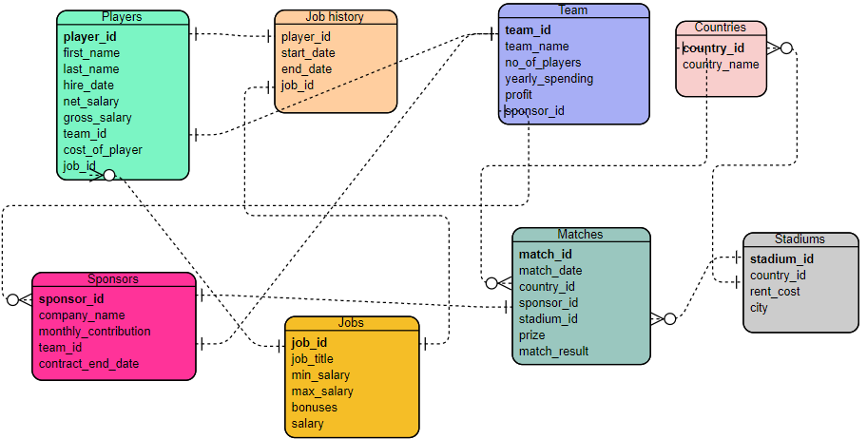

**Database construction**

**1.** Creating the database

The first step is to create the tables using the command CREATE.

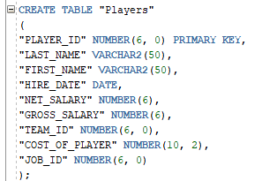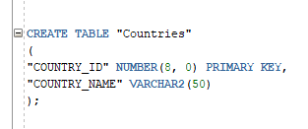

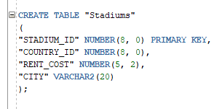

**2.** Altering tables

After I created all the tables according to the conceptual schema, I used ALTER commands: I renamed the table Match, I added a constraint to the match result because it has only 3 possible outcomes and I removed the column first_name from players because I considered there were too many fields and the player_id was already differentiating one from another (as it is the primary key). I also added other constraints but didn’t show all of them here.



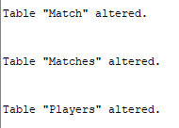

The result can be seen on the right, in the “tables” section.

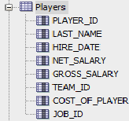

**Data update operations**

1. Insert values in the tables. This sample of code only contains some of the insert commands introduced.

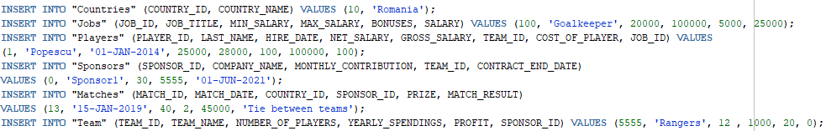

This is how the table Players looks after finishing this section of the project. The other tables were populated too.

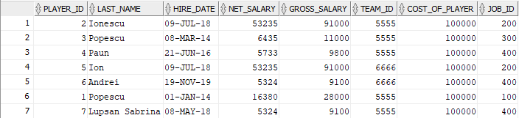

2. Update the net salary of each player by deducting social (25%) and health (10%) insurance and the income tax (10%) from the gross salary.

3. Set the bonuses field to 3100 for the job with the ID 300.

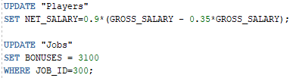

**Requirements for the database**

**1.** Display the minimum, maximum and the average salary for all the players in each team and compute the amount of taxes that is being payed from their salaries for each team. For average, round up to the biggest integer smaller than the selected number.

C:\Users\sabri\AppData\Local\Microsoft\Windows\INetCache\Content.Word\SELECT MIN MAX AVG.PNG



**2.** Display the match details where the host team got at least 1 point (=>the host team won or there was a tie).

C:\Users\sabri\AppData\Local\Microsoft\Windows\INetCache\Content.Word\host team won or tie.png

C:\Users\sabri\AppData\Local\Microsoft\Windows\INetCache\Content.Word\host team won or tie output.png

**3.** Display the country details and the match ID for all the matches that were played before the start of the year 2018.



C:\Users\sabri\AppData\Local\Microsoft\Windows\INetCache\Content.Word\output of match in 2017.png

**4.** Make transfers. Players with IDs 2, 3, 5, 6 and 7 should be in the team with the ID 5555 and the ones with the IDs 1 and 4 in the team with the ID 6666.

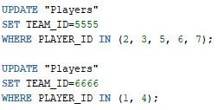

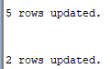

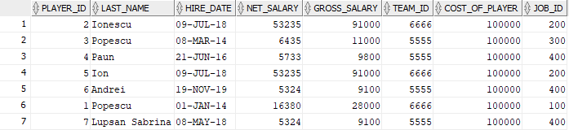

**5.** Update the table Players by setting the hire date of all the players whose name starts with “Ion” to be the 9th of July 2018.

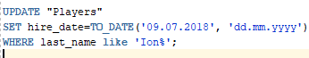



**6.** Display all the players from the team “Rangers” that have the net salaries no more than 9500 and at least 6000.

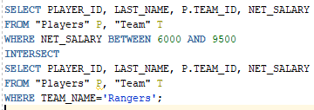



**7.** Display the match result and the country’s code for the matches played after the 2nd of January 2018.



**8.** Estimate the average amount of money a future player can win per month and order descending based on that to see which the most profitable career is.

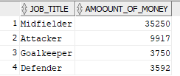

**9.** Create a sequence that generates the day of the month in which the next matches will be played. Every match is played once every 3 days. Suppose every month’s length is 30 days. Then, display the day of the first game of the year.

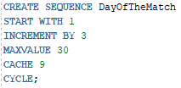

**10.** Create a view of the sponsors of the team with the ID = 5555. Then, change the contract of ‘Sponsor2’ to end on the 17th of October 2020. Display the final view.

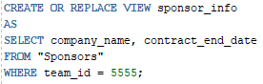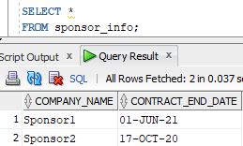

**11.** Add a new column in the table Players with the captain_id. There is only one captain for every team. The captain for the team with the ID 6666 is the player with the ID 1 and the captain for the team with the ID 5555 is the player with the ID 2.

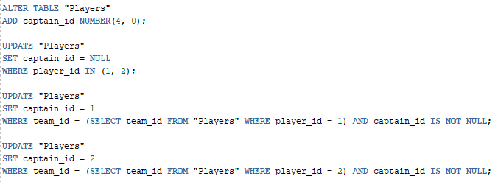

**12.** Display the level, last name, player ID of all the players (inferiors) with the captain whose last name is ‘Ionescu’, captain’s name and their name separated by a ‘/’.

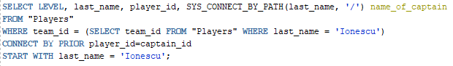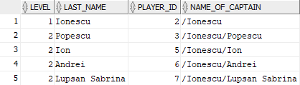

**13.** Display all the players who have an existent job ID (=> all the players, because that column is not nullable, since it is the primary key for the Jobs table).

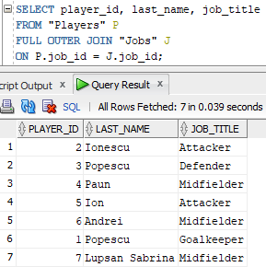

**14.** Display the countries and their continents for the countries with the ID bigger or equal than 20.

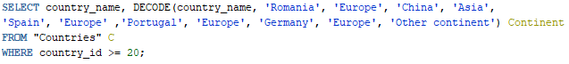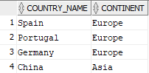

**15.** Display all of the players and their captain using the CASE function. If they don’t have a captain, their status is that they are a captain.

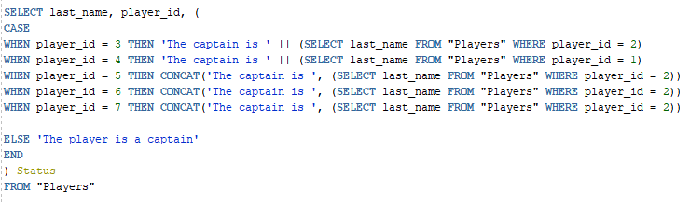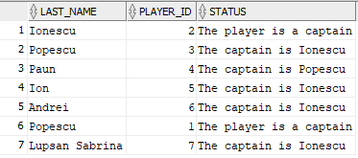

**16.** Update the table Team with the real number of players currently in the database.

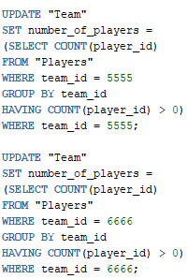

**17.** Display in how much time the contract of every sponsor will expire, in intervals of: <1 year, 1-2 years, > 2 years.

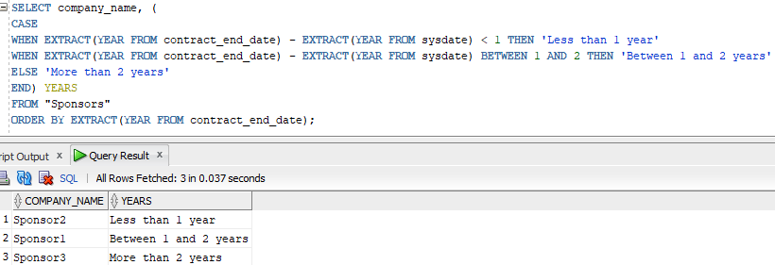

**18.** Display the last name of all the players that have the job title Attacker or Midfielder, their job title and their captain’s ID (if they are a captain, the captain_id = 0).

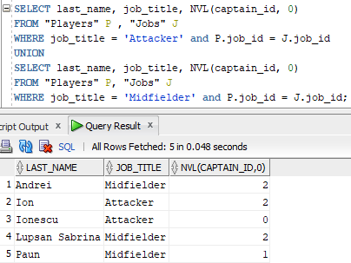

**19.** Display the matches with the prize bigger than 10.000 dollars but exclude the ones in which the guest team did not win or they tied.

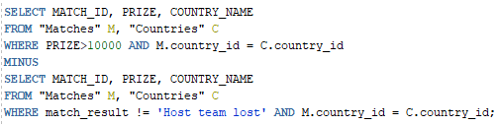



**20.** Create a synonym for the table “Job history” and then delete all the rows without deleting the table.

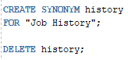

C:\Users\sabri\AppData\Local\Microsoft\Windows\INetCache\Content.Word\OUTPUT SYNONYM2.png

C:\Users\sabri\AppData\Local\Microsoft\Windows\INetCache\Content.Word\OUTPUT SYNONYM1.png

**21.** Create a unique index for the column “Salary” from the table “Jobs”.

